**Formula of R2 score:**

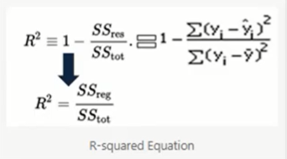

Where ,

* SS res -Residual Sum of Squares(Error=(Actual-predicted)
* SStotal- sum of average total (actual-mean)

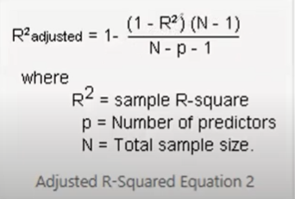

**Difference between r2 score and adjusted r2 score**

Every time you add a independent varible to a model. The R-squared increases, even if independent variable is insignificant . It never declines. Whereas Adjusted R- squred increses only when independent variabke is significant and affects dependent varible.

Adjusted R- squared value always be less than or equal to r-squared value.